Student Version

Section A – Program/Course details
Qualification code: | ICT40120 | Qualification title: | Certificate IV in Information Technology
Subject Code:  Unit code: | (CPRO3)  ICTPRG432  ICTPRG433  ICTPRG430 | Subject Title:  Unit title: | (C# Programming)  Develop data-driven applications  Test software developments  Apply introductory object-oriented language skills
Department name: | BDIT, Computer and Information Technology | CRN number: | Enter CRN number

Section B – Assessment task details
Assessment number: | 2 of 2 | Semester/Year: | 2/2025
Due date: | Session 18 | Duration of assessment: | 14 sessions
Assessment method | Portfolio | Assessment task results | ☒Ungraded result (S/NS)
 |  |  | ☐Other: Click here to enter text.

Section C – Instructions to students
Task instructions:

This assessment is comprised of 3 parts.
Part 1: Knowledge questions
Part 2: Develop a 2D-Shapes Calculator
Part 3: Develop Data-driven Applications

You will find detailed information for each step in the supporting document section.

For all parts in this assessment
- You are required to correctly answer all questions and complete all tasks as per instructions and assessment criteria to a satisfactory level for each question/task of this assessment to be given a satisfactory result by the assessor.
- Once you have completed all the questions, the assessment must be uploaded and submitted along with the signed assessment coversheet via Brightspace.
- If the result is not satisfactory within the enrolment period as per Holmesglen assessment procedure, you will be requested to resubmit within seven days of receiving feedback. You are permitted two resubmissions per assessment task.
- You must contribute to and abide by organisational standards including intellectual property and privacy laws.
- You may use the internet for research purpose however the learner’s answer must be in their own words.
- See supporting documentation for further instructions

Section D – Conditions for assessment
Conditions:
Student to complete and attach Assessment Submission Cover Sheet to the completed Assessment Task.
- This assessment is to be completed individually.
- You must meet all criteria listed in the marking guide to be satisfactory in this task.
- You may resubmit this task if not successful within the enrolment period as per Holmesglen conducting assessment procedure.
- This is an individual task; however, you are required to get information, feedback and ideas from your assessor, peers and industry to help complete the assessment planning guide.
- It is expected all documents will be completed and submitted electronically but if this is not possible, make alternative arrangements for submitting the documents with your assessor.
- You will have the opportunity to resubmit if any part of the assessment is deemed unsatisfactory
- You will be permitted TWO (2) resubmissions per assessment task
- You can appeal an assessment decision according to the Holmesglen Assessment Complaints and Appeals Procedure.
- If you feel you require special allowance or adjustment to this task, please decide with your assessor within one week of commencing this assessment.
- You may use the internet for research purpose only.
Equipment/resources students must supply: | Equipment/resources to be provided by the RTO:
Equipment/resources students must supply:  Students intending to learn remotely will require access to:  A PC/laptop with the following minimum specification:  Quad Core CPU  - Quad Core CPU  - 8GB of RAM  - CPU with minimum 2ghz processor or faster  - 200GB of Storage  - Access to internet connection (ADSL or cable connection desirable)  - Headset with microphone & webcam  Applications:  - Office 365 (including Word, Excel, PowerPoint…) – free to download through office.com login with your Holmesglen email  - WebEx - free to download  - 7Zip or an equivalent compression utility - free to download  - OneDrive or google drive account for storage  - Microsoft Visual Studio Community 2022 – free to download  - SQLite DB Browser – free to download | Equipment/resources to be provided by the RTO:  A Mac or PC/laptop with the following minimum specification:  Quad Core CPU  - Quad Core CPU  - 8GB of RAM  - CPU with minimum 2ghz processor or faster  - 200GB of Storage  - Access to internet connection  Applications:  - Office 365 (including Word, Excel, PowerPoint…)  - WebEx  - 7Zip  - OneDrive  - Microsoft Visual Studio Community 2022  - SQLite DB Browser

Section E – Marking Sheet - Student Answer Sheet
Subject code:  Unit code: | (CPRO3)  ICTPRG432  ICTPRG433  ICTPRG430 | Subject Title:  Unit title: | (C# Programming)  Develop data-driven applications  Test software developments  Apply introductory object-oriented language skills

Criteria for assessment |  | Satisfactory |  | Comment
 |  | Yes | No
The following has been submitted for assessment:
Assessment document with all questions answered, and coversheet signed |  | ☐ | ☐
All the source codes |  | ☐ | ☐
Marking criteria for each product document/s supplied:
Part 1 - Knowledge questions
1 | Learner correctly discussed constructor. | ☐ | ☐
2 | Learner correctly discussed object aggregation | ☐ | ☐
3 | Learner correctly discussed basic programming structures, sequential, condition, loop. | ☐ | ☐
4 | Learner correctly discussed member field and member method in a C# class | ☐ | ☐
5 | Learner correctly discussed static member field and static member method in a C# class | ☐ | ☐
6 | Learner correctly discussed the debugging and testing approaches and techniques in software development | ☐ | ☐
7 | Learner correctly discussed software development life cycle | ☐ | ☐
8 | Learner correctly listed common organizational documentation types and their purposes in SDLC | ☐ | ☐
9 | Learner correctly discussed small-size application development processes | ☐ | ☐
10 | Learner correctly discussed the processes, tools and techniques for testing small-size applications | ☐ | ☐
11 | Learner correctly researched auto test frameworks for the following languages | ☐ | ☐
12 | Learner correctly described software test concept “IPO” (Inputs, Process and Outputs) | ☐ | ☐
13 | Learner correctly explained the following data structure - array, tree | ☐ | ☐
14 | Learner correctly discussed at least 5 organisational guidelines and procedures applicable to software development and testing frameworks | ☐ | ☐
15 | Learner correctly discussed software defect management process | ☐ | ☐
16 | Learner correctly discussed relational database management systems, functions and tools | ☐ | ☐
17 | Learner correctly discussed the concept of application programming interfaces. What is operation system API, libraries API, web API? | ☐ | ☐
18 | Learner researched and discussed at least 3 different data providers and vendors | ☐ | ☐
19 | Learner correctly discussed the principles of Structured Query Language (SQL) | ☐ | ☐
20 | Learner correctly discussed the organisational guidelines and procedures applicable in assisting the development of data-driven applications | ☐ | ☐
Part 2 – Develop a 2D-Shape Calculator
1.1 | Learner read the project brief for this application, review and clarify user requirements with user. And list all user requirements using bullet points. | ☐ | ☐
1.2 | Learner plan and determine the class hierarchy (inheritance tree) to satisfy user requirements. | ☐ | ☐
1.3 | Learner plan and determine the member fields and methods for all classes. | ☐ | ☐
1.4 | Learner explained “inheritance”, “polymorphism” and “overriding methods”. | ☐ | ☐
1.5 | Learner implement all classes according to the design above using an OOP programming language (e.g. C#). | ☐ | ☐
1.6 | Learner implement two versions of constructors for all classes with member fields | ☐ | ☐
1.7 | Learner implement the console user interface according to the requirements | ☐ | ☐
1.8 | Learner correctly implemented polymorphism for code extensibility | ☐ | ☐
1.9 | Learner applied documentation conventions and documented the application according to organisational documentation conventions | ☐ | ☐
1.10 | Learner applied code conventions to organisational requirements | ☐ | ☐
1.11 | Learner communicated relationships between ideas and information, in a style appropriate to the audience and purpose, and selects the vocabulary, grammatical structures and conventions appropriate to the text, in relation to coding, recording outcomes, and documenting activitie. | ☐ | ☐
1.12 | Learner selected from, and flexibly applies, mathematical and problem-solving strategies and techniques, in a programming context | ☐ | ☐
1.13 | Learner recognised and followed, explicit and implicit standard and meets expectations associated with own role when developing code that is compliant with standards and guidelines | ☐ | ☐
1.14 | Learner used a formal decision-making process, identifying and evaluating several choices against a limited set of criteria, when selecting language data types, operators and expressions | ☐ | ☐
1.15 | Learner evaluated the effectiveness of decisions, in terms of how well they meet the stated design specifications | ☐ | ☐
1.16 | Learner used analytical processes to decide on a course of action when debugging | ☐ | ☐
1.17 | Learner utilised features within applications in order to develop software programs | ☐ | ☐
1.18 | Learner recognised, and used language and symbols, when applying the coding syntax | ☐ | ☐
1.19 | Learner actively identified systems, devices and applications with the potential to meet current and future needs regarding programming | ☐ | ☐
1.20 | Learner reviewed application against user requirements to ensure user requirements are satisfied | ☐ | ☐
1.21 | Learner presented application to user and obtain user acceptance | ☐ | ☐
Part 3 – Develop Data-driven Applications
3.1 | Learner read the project brief for this application, review and clarify user requirements with user. And list all user requirements using bullet points. | ☐ | ☐
3.2 | Learner plan and determine the class hierarchy (inheritance tree) to satisfy user requirements. | ☐ | ☐
3.3 | Learner plan and determine the member fields and methods for all classes. | ☐ | ☐
3.4 | Learner explained “inheritance”, “polymorphism” and “overriding methods”. | ☐ | ☐
3.5 | Learner implement all classes according to the design above using an OOP programming language (e.g. C#). | ☐ | ☐
3.6 | Learner implement two versions of constructors for all classes with member fields | ☐ | ☐
3.7 | Learner implement the console user interface according to the requirements | ☐ | ☐
3.7.1 | Learner query data from data source according to task requirements | ☐ | ☐
3.7.2 | Learner applied documentation conventions and documented the application according to organisational documentation conventions | ☐ | ☐
3.7.3 | Learner retrieve and manage results sets from data source | ☐ | ☐
3.7.4 | Learner manage exceptions when retrieving data | ☐ | ☐
3.7.5 | Learner document code and database connectivity according to organisational procedures | ☐ | ☐
3.8 | Learner research disconnected data management strategy | ☐ | ☐
3.9 | Learner read and write files using programming language | ☐ | ☐

Assessment Submission Cover Sheet (VET)
Student Declaration – Must be signed before submission
By submitting this assessment task and signing the below, I acknowledge and agree that:
• This completed assessment task is my own work.
• I understand the serious nature of plagiarism and I am aware of the penalties that exist for breaching this.
• I have kept a copy of this assessment task.
• The assessor may provide a copy of this assessment task to another member of the Institute for validation and/or benchmarking purposes.
Student ID: |  | Student name:
Submission or observation date:
Student signature
For electronic submissions: By typing your name in the student signature field, you are accepting the above declaration.

Section F – Feedback to Student
Has the student successfully completed this assessment task? |  |  |  |  | Yes | No
 |  |  |  |  | ☐ | ☐
Additional Assessor comments (as appropriate):

Resubmission allowed: | Yes ☐ | No ☐ | Resubmission due date:
Assessor name:
Assessor signature:
Date assessed:

Part 1 – Knowledge Questions
1. What is constructor in Object Oriented Programming (OOP)
Answer:

A constructor in OOP is a special method within a class that automatically runs when an object is created. The main purpose is to initialize the object’s member fields and set up its starting state so the object is ready to use. A constructor has the same name as the class, does not have a return type, and provides default values or accept parameters to customise the new object. A constructor can help maintain reliability and structure in OOP programs by ensuring every object begins in a valid and predictable condition.

2. What is Object Aggregation (the “is-a” or “part-of”). You may use an example to explain.
Answer:
Object aggregation is a concept whereby one object is made up of other independent objects, representing a “part-of” relationship: one class using another class as a component rather than inheriting from it. Aggregation allows objects to combine forming more complex structures while still remaining separate and reusable. For example, a Car object can contain Engine, Wheel, and Seat objects; each of these parts exists independently. Therefore, combined they form the complete car. This helps organize code, improve modularity, and reflect real-world relationships in software design.
3. Discuss the 3 basic programming structures, sequential, condition, loop.
Answer:
Sequential | Statements running in order, one after another, from top to bottom under a default behaviour in most programs.
Condition | Allowing programs to make decisions using statements like If, Else if or Switch. Different codes execute depending on certain conditions or user input.
Loop | Runs repetition by running a block of code multiple times using constructs such as For, While, or Do-While. Useful for performing tasks repeatedly until a specific condition is met.

4. What is member field and member method in a C# class
Note member field is also referred as instance variable and member method is also refer to as instance method in some other languages
Answer:
Member fields and member methods refer to the data and behaviours that belong to each object created from a class respectively. A member field contains variables declared inside the class storing information specific to each object e.g. name or age. A member method is the function within the class that defines the actions the object can perform e.g. calculating a value.
5. What is static member field and static member method in a C# class
Note static member field is also referred as class variable and static member method is also refer to as class method in some other languages
Answer:
In C#, static member fields and static member methods belong to the class itself rather than to individual objects created from the class. A static field is a variable that is shared across al instances, where every object accesses the same value rather than having its own copy. A static method is a function that can be called directly on the class without creating an object, useful for utility functions or shared operations. Static members are accessed using the class name instead of an instance, they help manage values or behaviours that need to be consistent and available throughout the program.

6. Discuss the debugging and testing approaches and techniques in software development
Answer:

Debugging and testing are essential stages in software development used to identify, isolate, and fix issues in a program. Debugging locates errors by using breakpoints, stepping through the code, inspecting variables, and reviewing error messages. On the other hand, testing ensures that the application is working based on the requirements through approaches such as unit testing, integration testing and system testing. These techniques help improve reliability, reducing defects and ensuring software behaves under different scenarios.
Test plan file name = ShapesCalculator_TestPlan.docx

7. What is the Software Development Life Cycle (SDLC), and why is it important in software development? Describe the key phases involved and explain how each phase contributes to the successful creation of software.
Answer:
The Software Development Life Cycle is a structured process used to plan, develop, test and deliver high-quality software. It is important because it provides a clear framework that helps teams manage complexity, reducing errors, improving communication, ensuring final product meets under requirements. The SDLC typically includes several key phases: planning, where goals, scope, and feasibility are defined; analysis, where user and system requirements are gathered; design, where the system architecture, data structures, and interface layouts are created; implementation, where developers write the actual code; testing, where the software is verified for correctness, reliability, and usability; deployment, where the system is released to users; and maintenance, where updates, bug fixes, and improvements are made. Each phase contributes to building software in an organised, predictable, and efficient way.
8. List and describe common types of documentation used in the Software Development Life Cycle (SDLC). For each type, explain its purpose and how it supports the development process
Answer:
Common documentation types used in the Software Development Life Cycle (SDLC) include requirements documentation, which outlines what the software must do and ensures all stakeholders share the same understanding; design documentation, which describes the architecture, data structures, interfaces, and system components that guide developers during implementation; and technical documentation, which includes code comments, API references, and system configuration details to support future maintenance. Additionally, test documentation such as test plans and test cases helps ensure the software is validated against requirements, while user documentation—like manuals or online help—guides end users in operating the system. Together, these documentation types support clear communication, consistent development, easier debugging, and long-term maintainability.
9. Discuss the typical development process for small-size software applications. What steps are usually involved, and how might they differ from those used in large-scale projects?
Answer:
The development process for small-size software applications usually follows a simplified version of the SDLC, focusing on speed, flexibility, and minimal documentation. Typical steps include gathering basic requirements, designing a simple structure or prototype, implementing the code, performing unit and system testing, and finally deploying the application. These projects often involve a single developer or a small team, so communication is direct and decisions are made quickly. In contrast, large-scale projects require more formal processes such as detailed requirement analysis, extensive design documentation, strict version control, multiple testing stages, project management oversight, and collaboration across larger teams. As a result, small applications are faster to build and more flexible, while large projects require structured planning and coordination to ensure consistency and quality.
10. Discuss the testing processes, tools, and techniques commonly used for small-size software applications. How do these ensure the application works correctly and meets user needs?
Answer:
Testing small-size software applications typically involves simple but effective processes such as unit testing, integration testing, and manual system testing. Tools like Visual Studio’s built-in test framework, NUnit, or basic debugging tools are commonly used to verify individual functions and check how different parts of the application work together. Techniques such as boundary value analysis, equivalence partitioning, and step-by-step debugging help identify errors early and ensure the program behaves as expected under different inputs. Because small applications often have fewer features and are developed by a small team, testing can be more flexible and less formal, focusing on quick validation and direct user feedback. These processes ensure the application functions correctly, meets user requirements, and remains stable and reliable.
11. Research industry standard auto test frameworks for the following languages
Answer:
Language | Auto test framework name | Official site URL
C# | NUnit | https://nunit.org/
Python | PyTest | https://pytest.org/
JavaScript | Jest | https://jestjs.io/

12. Describe the software testing concept of IPO (Inputs, Process, Outputs). How can this model be used to design and test applications effectively?
Answer:
The IPO model describes how programs handle data: inputs are received, processes transform the data using logic, and outputs present the results. This model helps developers design functions more clearly and create effective test cases that verify each input produces the correct output.

13. Explain the following data structure - array, tree
Answer:
Array (or list):
An array is an ordered collection of elements stored in continuous memory, allowing fast access using an index.
Tree:
A tree is a hierarchical structure made of nodes, starting with a root and branching out into children. Trees are useful for representing relationships such as file systems and search paths.
14. Discuss at least 5 organisational guidelines and procedures applicable to software development and testing frameworks
Answer:
Organisations commonly enforce coding standards for naming and formatting, version control policies for managing changes, documentation rules for commenting and reporting, security procedures for handling sensitive data, and testing guidelines for writing and executing test cases. These ensure consistency and quality across development.

15. Discuss software defect management process
Answer:
Defect management involves identifying, logging, prioritising, fixing, and retesting defects. Each issue is tracked through a formal process to ensure it is resolved correctly and does not reappear. This helps maintain software quality and ensures issues are addressed systematically.
16. Discuss relational database management systems, functions and tools.
You may use any database management systems you have used for discussion. For example MS SQL Server, SQLite DB Browser, PHPMyAdmin …
Answer:
RDBMS tools like SQLite, SQL Server, or MySQL store data in tables and use SQL to manage data. They support querying, updating, and maintaining data consistency through relationships and constraints. Tools like SQLite Browser or SSMS help developers inspect and manage database contents easily.

17. Discuss the concept of application programming interfaces. What is operation system API, libraries API, web API?
Answer:
An API allows programs to communicate with other software components. Operating system APIs interact with OS services such as files or processes. Library APIs provide reusable functions from software libraries. Web APIs allow communication over the internet using formats like JSON and HTTP.

18. Research and discuss at least three different data providers or access technologies that allow programs to connect and interact with databases. For each one, explain the vendor or technology, what type of databases it connects to, and how it is used in programming (e.g., ADO.NET, ODBC, PDO).
Answer:
ADO.NET is a Microsoft technology used to connect to databases like SQL Server and SQLite. ODBC is a universal connector that allows programs to access many different databases through a standard interface. PDO is a PHP-based data layer that supports multiple databases such as MySQL and SQLite.

19. What are the core principles of Structured Query Language (SQL)? Explain how these principles guide the way data is stored, managed, and accessed in a relational database.
Answer:
SQL is based on defining data structures, manipulating data, and retrieving information from tables. It uses commands such as SELECT, INSERT, UPDATE, and DELETE. Principles such as normalization, relationships, and constraints ensure data is structured efficiently and accessed reliably.

20. What are the organisational guidelines and procedures applicable in assisting the development of data-driven applications?
Answer:
These guidelines include using secure access methods such as parameterised queries, following coding standards, documenting database connections, managing versions through source control, and performing proper testing. Together, they help ensure that applications handling data are secure, maintainable, and reliable.

Part 2 - Develop a 2D-Shapes Calculator

Development requirements

Here are the requirements for the “2D-Shapes Calculator” program.
1 | User is able to use a command line-based console interface to operate the calculator.
2 | User is able to choose the target shape from a predefined list, including square, rectangle, circle, trapezoid.
3 | User is able to choose what to calculate for each selected geometry shape from a predefined list, including area and perimeter.

You are required to
- Design and develop a software program that meets the above requirements
- Develop a test plan that covers the requirements using provided template
- Execute the test plan to verify the program
- Generate a test report using provided template

You are also required to follow the questions in the step 1 and step 2 below to finish all the tasks and answer all the questions.

Development environment
- Visual studio
- SQLite DB-browser

Organisational guidelines
- C# Coding Conventions - https://docs.microsoft.com/en-us/dotnet/csharp/fundamentals/coding-style/coding-conventions
- Software test principles and guidelines. See attached file below.

Step 1 – Software design & development
In this step, you are required design and develop the application using a selected programming language (e.g. C#).
1.1. Read the project brief for this application, review and clarify user requirements with user. And list all user requirements using bullet points.
Answer:
- The user must operate the application using a console-based command-line interface.
- The user must be able to choose a shape from a predefined list: square, rectangle, circle, and trapezoid.
- The user must be able to choose whether they want to calculate the area or perimeter of the selected shape.
- The system must accept user input for the required dimensions of each shape.
- The system must correctly calculate and display the result based on user choice.

1.2. Plan and determine the class hierarchy (inheritance tree) to satisfy user requirements. You are required to use the following notation to represent the inheritance relationship.
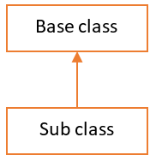
Answer:
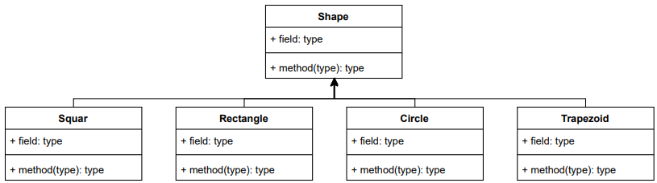

1.3. Plan and determine the member fields and methods for each class documented in question 2 above. You are required to use the following notation to represent a class.
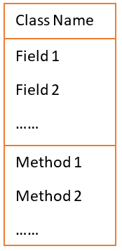
Answer:

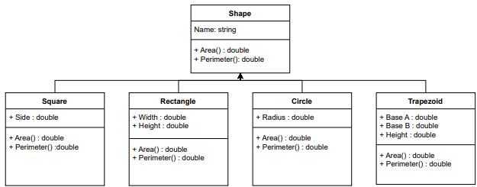

1.4. In terms of object-oriented programming, explain “inheritance”, “polymorphism” and “overriding methods”. You may explain the three terms by using an example.
Answer:
Terms | Your answers
inheritance | Inheritance allows one class (a child or subclass) to reuse the attributes and methods of another class (the parent).  In this project, Square, Rectangle, Circle, and Trapezoid all inherit from the base class Shape, meaning they automatically receive its methods like Area() and Perimeter().
polymorphism | Polymorphism allows different classes to use the same method name but produce different behaviours.  In this project, every shape class has its own version of Area() and Perimeter(), so the same method call behaves differently depending on the shape object used.
overriding methods | Overriding is when a subclass replaces a method from its parent class with its own implementation.  Each shape class overrides the Area() and Perimeter() methods from Shape to calculate the correct values for its specific shape.

1.5 Implement all classes according to the design above using an OOP programming language (e.g. C#). You need to make sure:
- Inheritance and polymorphism (overriding methods) have been correctly implemented.
- Code conventions are followed
- Codes are fully documented using comments
Provide a screenshot of the codes for each class definition.
Answer:
Shape | 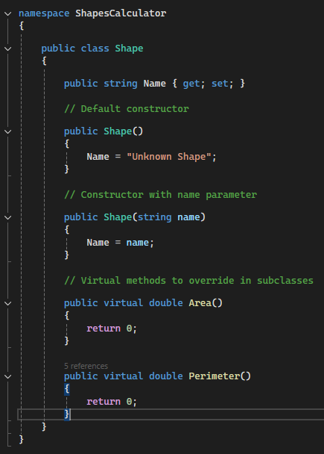
Square | 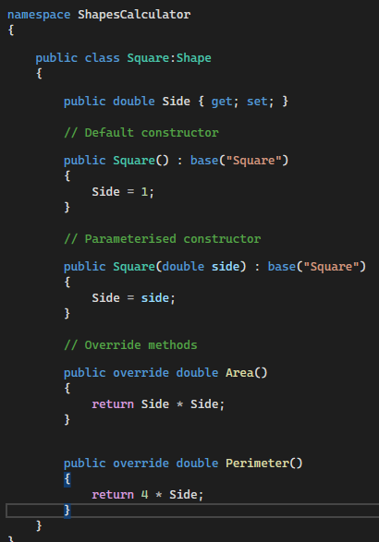
Rectangle | 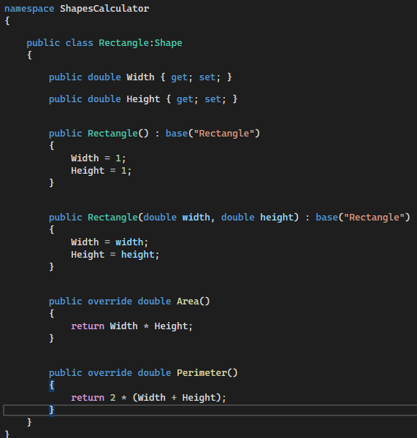
Circle | 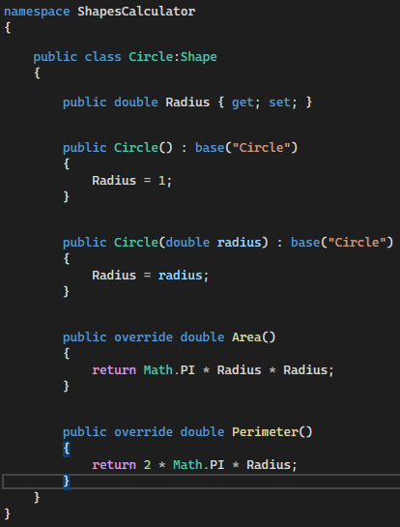
Trapezoid | 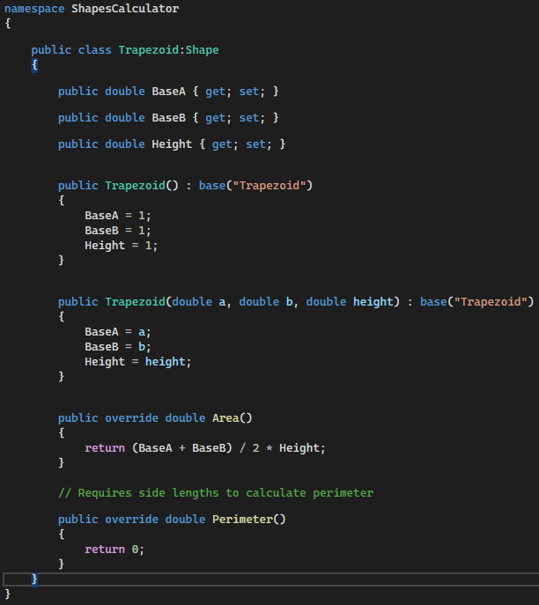

Add more rows as you need in the table above to cover all classes.

☒ I have followed code conversions
☒ I have fully documented using comments

1.6 Implement two versions of constructors for all classes with member fields.
- One constructor accepts zero parameter and initialize each member fields to a reasonable default value.
- The other constructor accepts a number of parameters for initializing all member fields.
Provide a screenshot of the two constructors for each class.
Answer:
Class Name | Constructor #1 – without parameter  Screenshot | Constructor #2 – with parameter  Screenshot
Shape | 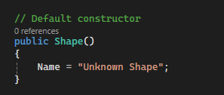 | 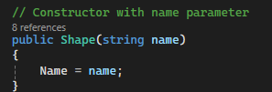
Circle | 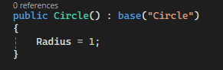 | 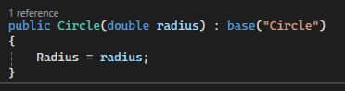
Rectangle | 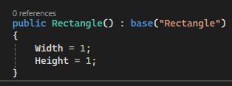 | 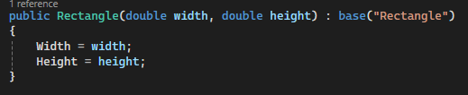
Square | 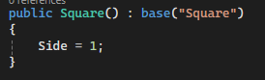 | 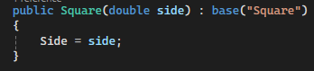
Trapezoid | 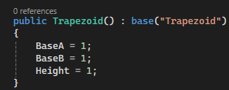 | 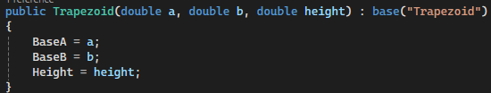

Add more rows as you need in the table above to cover all classes.
1.7 Implement the console user interface according to the requirements. Provide a screenshot of the codes.
You need to make sure:
- Code conventions are followed
- Codes are fully documented using comments
Answer:
Your screenshot
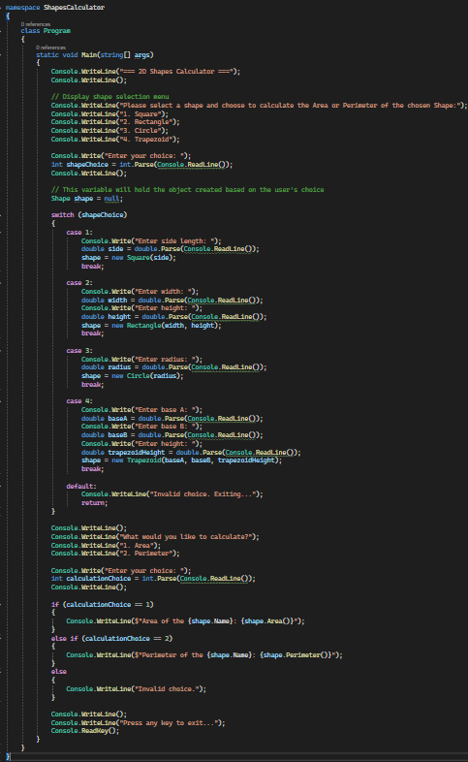

☒ I have followed code conversions
☒ I have fully documented using comments

Skills to be observed for step 1 by assessor |  | 1. Date: |  | 2. Date: |  | Comment
 |  | Satisfactory |  | Satisfactory
 |  | Yes | No | Yes | No
1.8 | Learner correctly implemented polymorphism for code extensibility | ☐ | ☐ | ☐ | ☐
1.9 | Learner applied documentation conventions and documented the application according to organisational documentation conventions | ☐ | ☐ | ☐ | ☐
1.10 | Learner applied code conventions to organisational requirements | ☐ | ☐ | ☐ | ☐
1.11 | Learner communicated relationships between ideas and information, in a style appropriate to the audience and purpose, and selects the vocabulary, grammatical structures and conventions appropriate to the text, in relation to coding, recording outcomes, and documenting activitie. | ☐ | ☐ | ☐ | ☐
1.12 | Learner selected from, and flexibly applies, mathematical and problem-solving strategies and techniques, in a programming context | ☐ | ☐ | ☐ | ☐
1.13 | Learner recognised and followed, explicit and implicit standard and meets expectations associated with own role when developing code that is compliant with standards and guidelines | ☐ | ☐ | ☐ | ☐
1.14 | Learner used a formal decision-making process, identifying and evaluating several choices against a limited set of criteria, when selecting language data types, operators and expressions | ☐ | ☐ | ☐ | ☐
1.15 | Learner evaluated the effectiveness of decisions, in terms of how well they meet the stated design specifications | ☐ | ☐ | ☐ | ☐
1.16 | Learner used analytical processes to decide on a course of action when debugging | ☐ | ☐ | ☐ | ☐
1.17 | Learner utilised features within applications in order to develop software programs | ☐ | ☐ | ☐ | ☐
1.18 | Learner recognised, and used language and symbols, when applying the coding syntax | ☐ | ☐ | ☐ | ☐
1.19 | Learner actively identified systems, devices and applications with the potential to meet current and future needs regarding programming | ☐ | ☐ | ☐ | ☐
1.20 | Learner reviewed application against user requirements to ensure user requirements are satisfied | ☐ | ☐ | ☐ | ☐
1.21 | Learner presented application to user and obtain user acceptance | ☐ | ☐ | ☐ | ☐

Step 2 – Software test
2.1 Identify unit test requirements for each class and list all requirements with bullet points.
Answer:

Shape Class
- Area() should return 0 for the base class.
- Perimeter() should return 0 for the base class.
- Default constructor should set Name = "Unknown Shape".
- Parameterised constructor should correctly assign the Name property.
Square Class
- Default constructor should set Side = 1.
- Parameterised constructor should correctly assign Side.
- Area() should return Side × Side.
- Perimeter() should return 4 × Side.
- Should correctly override virtual methods from Shape.
Rectangle Class
- Default constructor should set Width = 1 and Height = 1.
- Parameterised constructor should correctly assign Width and Height.
- Area() should return Width × Height.
- Perimeter() should return 2 × (Width + Height).
- Should correctly override Area() and Perimeter().
Circle Class
- Default constructor should set Radius = 1.
- Parameterised constructor should correctly assign Radius.
- Area() should return π × Radius².
- Perimeter() (circumference) should return 2 × π × Radius.
- Should correctly override methods from Shape.
Trapezoid
- Default constructor should set BaseA = 1, BaseB = 1, Height = 1.
- Parameterised constructor should correctly assign BaseA, BaseB, Height.
- Area() should return (BaseA + BaseB) / 2 × Height.
- Perimeter() should return 0 (because it is not fully implemented).
- Should correctly override Area() and Perimeter().
2.2 Identify system test requirements for the application and list all requirements with bullet points
Answer:

- The system should correctly display the main menu of shape options.
- The system should accept valid user input for choosing a shape.
- The system should reject invalid shape choices and show an error message.
- The system should prompt the user for the correct fields (side, width, height, radius, etc.) based on the selected shape.
- The system should correctly convert all numeric inputs (e.g., Console.ReadLine() → double).
- The system should create the appropriate shape object based on user selection.
- The system should correctly calculate Area for all shape types.
- The system should correctly calculate Perimeter where implemented (Square, Rectangle, Circle).
- For Trapezoid, the system should calculate Area and return 0 for Perimeter (as designed).
- The system should let users choose between calculating Area or Perimeter.
- The system should handle invalid calculation choices gracefully.
- The system should clearly display the result in the correct format.
- The system should exit only when the user is done and presses a key.
- The system should not crash due to invalid input (e.g., letters instead of numbers).
2.3 Discuss and confirm the above development requirements with a member in software development team.
Note: The member in software development team can be role played by another student. You are required to discuss the following items in the meeting.
Answer:
Participants/roles | Jeff (Developer)
Meeting date
Scope of test | - All shape classes (Shape, Square, Rectangle, Circle, Trapezoid).  - Constructors (default & parameterised) must initialise values correctly.  - Area() and Perimeter() methods must return correct calculations.  - Console application must allow valid user input and correct output display.
Types of tests | - Unit tests (class-level testing).  - System testing (end-to-end test of the console application).
- Tools | - Visual Studio (C# IDE).  - .NET Runtime (to run the console app).  - Optional: MSTest/NUnit/xUnit frameworks for unit testing
Benefits | - Ensures each class works independently (unit test).  - Ensures the whole application flows correctly (system test).  - Early detection of errors reduces debugging time.  - Confirms that requirements (area, perimeter, constructors, UI) are fully met.  - Makes the application more reliable and easier to maintain.

2.4 Identify organisational guidelines and frameworks related to testing. List them all using bullet points
Answer:

- IEEE 829 (Standard for Software Test Documentation) – Provides templates and structure for test plans, test design, test cases, and test reports.
- IEEE 1012 (System and Software Verification and Validation) – Defines V&V processes to ensure the system meets requirements.
- ISO/IEC/IEEE 29119 Software Testing Standard – International standard covering test processes, documentation, techniques, and keyword-driven testing.
- ISTQB Testing Framework – Industry-recognised body of knowledge defining testing terminology, levels, and processes.
- Agile Testing Principles (Scrum/XP) – Encourages continuous testing, test-driven development (TDD), and early detection of defects.
- Organisation’s internal QA/testing policy – Defines company-specific rules for test approvals, version control, documentation and coding/testing practices.
- Risk-based testing guidelines – Prioritises test activities based on likelihood and impact of failures.
- Continuous Integration (CI) testing guidelines – Ensures all code changes are automatically tested using CI tools (GitHub Actions, Azure DevOps, Jenkins).
- Code review and static analysis guidelines – Internal processes for peer review, linting, and compliance with coding standards.

2.5 Discuss at least three test-case design techniques and explain how they are applied in your test case design.
Answer:
Test-case design technique #1
Discuss this technique

Equivalence Partitioning is a test design technique where input values are divided into logical groups (partitions). Each group represents a set of valid or invalid inputs that should be treated the same by the system. Instead of testing every possible value, you test one value from each partition.

This reduces the number of test cases while still providing good coverage.

Explain how you apply this technique in your test case design

- For the Shapes Calculator:

  - For Square(side), partitions include:

    - Valid: positive numbers (e.g., 3, 5, 10)

    - Invalid: zero, negative numbers, non-numeric

  - For Circle(radius):

  - Valid: radius > 0

  - Invalid: radius ≤ 0

  - For Rectangle(width, height):

  - Valid: width > 0 AND height > 0

  - Invalid: width ≤ 0, height ≤ 0

- Only one value from each partition needs to be tested.
  - Example:
    - Test Radius = 1 (valid)
    - Test Radius = –5 (invalid)

Test-case design technique #2
Discuss this technique

Boundary Value Analysis focuses on the edges (boundaries) of input ranges because errors often occur there. Instead of testing random valid numbers, BVA tests values just below, at, and just above the boundary.

Explain how you apply this technique in your test case design

For the Shapes Calculator:
- For Square(side):
Boundary = 1
  - Test: 0 (invalid), 1 (valid minimum), 2 (just above minimum)
- For Circle(radius):
  - Test: 0 (invalid), 1 (valid boundary)
- For Rectangle(width, height):
  - Width boundary tests: 0, 1, 2
  - Height boundary tests: 0, 1, 2
This ensures the calculator handles minimum acceptable values correctly and rejects invalid ones.

Test-case design technique #3
Discuss this technique

Error Guessing relies on the tester’s experience to guess common mistakes or edge scenarios that might cause the program to fail. These are inputs not covered by formal techniques like EP or BVA.

Explain how you apply this technique in your test case design

For the Shapes Calculator, we design tests based on common user mistakes:
- Entering letters instead of numbers (e.g., “abc”)
- Entering empty input
- Entering very large numbers
- Choosing an invalid menu option (e.g., 0 or 9)
- Entering a decimal where an integer is expected
Error Guessing helps test how well the calculator responds to incorrect or unexpected user input, ensuring the program is robust.

2.6 Develop test plan and test cases using provided template.
You are required to apply the test-case design techniques discussed above and develop TWO test cases with EACH technique.
Write the submitted test plan file name in the answer box below.
Answer:
< Software_Test_Plan_ShapesCalculator >

2.7 Develop unit test procedures using an auto testing framework (e.g. Visual Studio Unit Testing). Provide a screenshot of the unit test codes (if the codes are too long, screenshot 2 test case for this question and your teacher will check all the codes in your code submission).
Answer:

Develop unit test procedures using an automatic testing framework, such as:
- Visual Studio Unit Testing (MSTest)
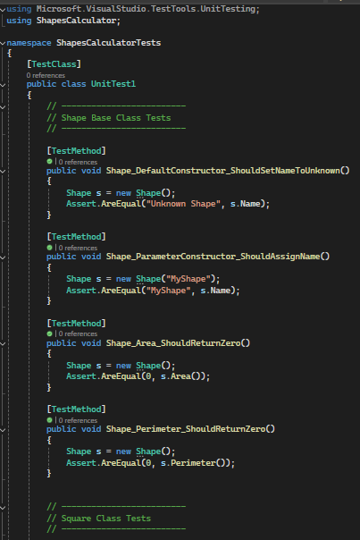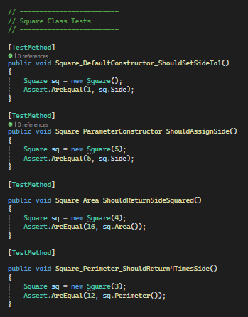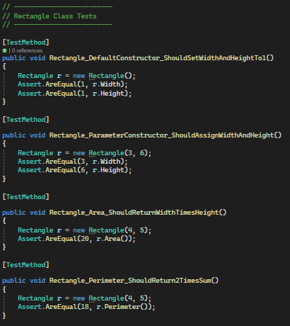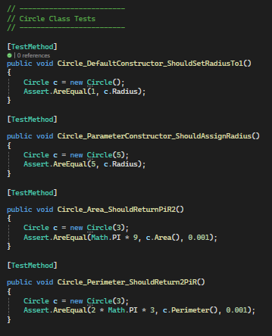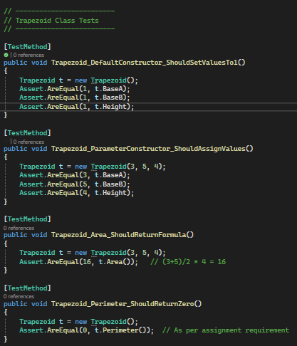

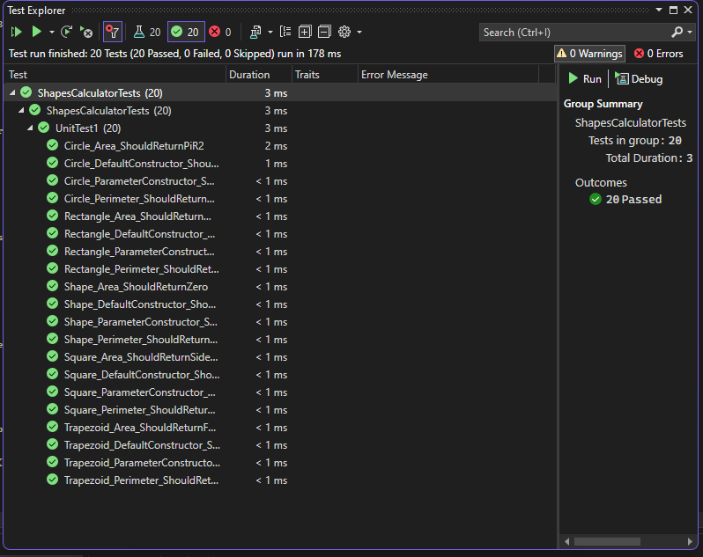

2.8 Perform manual test according to system test plan, screenshot the test results (for at least two test cases).
Answer:

Test case for calculating area of square:

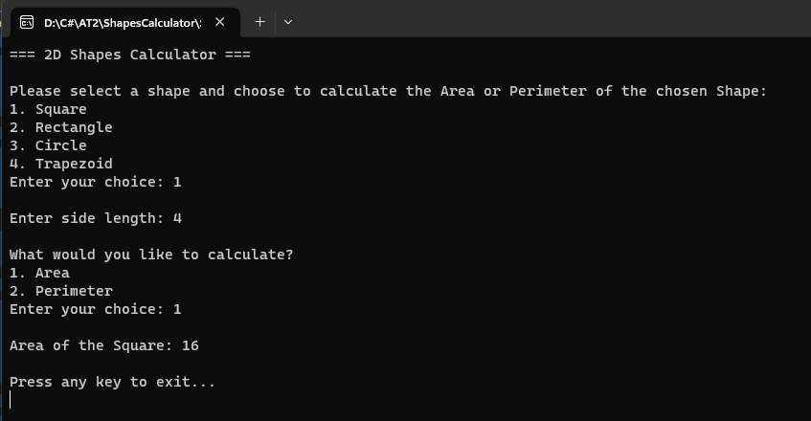

Test case for calculating circle perimeter:
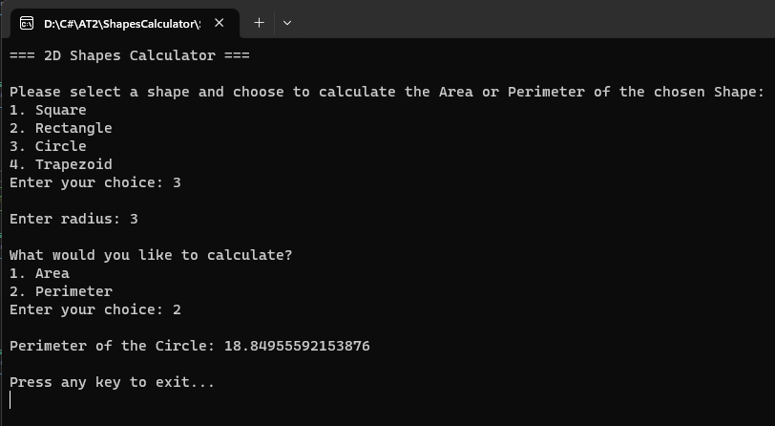

2.9 Perform auto test according to unit test plan, screenshot the test results (for at least two test cases).
Answer:

Screenshot attached shows the automatic test execution using MSTest.
All 20 unit tests passed successfully with 0 errors.
This confirms the system behaves correctly according to the unit test plan.



2.10 Discuss and confirm the above test results with a member in software development team.
Note: The member in software development team and be role played by another learner.
Answer:
Participants/roles | Student – Developer and Tester
Meeting date | 26 November 2025
Meeting minutes | - Reviewed the manual testing results (Square area test and Circle perimeter test).  - Confirmed that the outputs matched the expected values based on the system test plan.  - Reviewed the unit test results in Visual Studio Test Explorer.  - All unit tests (20/20) passed successfully with no errors.  - Discussed that the program behaves correctly for valid input and calculations for all shape types.  - Agreed that the application meets all test requirements and is ready for submission.

2.11 Produce and save test reports using provided template.
Write the submitted test plan file name in the answer box below.
Answer:
ShapesSolution_TestReport.docx

2.12 Manage defects and review software, amending further defects. You are required to record how did you managed defect for at least one issue based on the test results using the template below.
Answer:
Issue description:

During manual testing, the output for Circle Perimeter displayed a long floating-point number (e.g., 18.84955592153876).
Although mathematically correct, the value is not user-friendly and does not match the typical rounded output expected in system test cases.

Code review and root cause analysis:

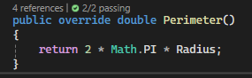

This is correct, but the Console UI prints the raw double value without formatting, causing long decimal outputs.

The unit tests passed because they include a tolerance (0.001), but the system test requires readable rounded outputs, and this mismatch is considered a defect in usability.

Resolution description:

To fix the issue, the console output for Perimeter and Area was updated to format numerical results to two decimal places, e.g.:
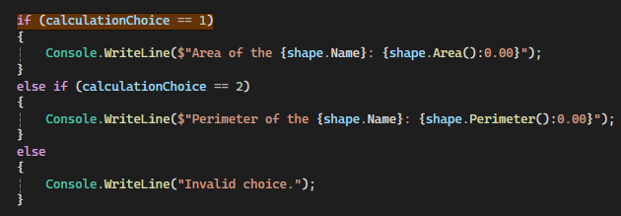

This ensures that system test results match expected values (e.g., 18.85 instead of 18.84955592153876) and improves UI readability.

Skills to be observed for this step 2 by assessor |  | 1. Date: |  | 2. Date: |  | Comment
 |  | Satisfactory |  | Satisfactory
 |  | Yes | No | Yes | No
2.13 | Learner identified test and script requirements including data structures | ☐ | ☐ | ☐ | ☐
2.14 | Learner analysed and identified test data using multiple test-case design techniques. | ☐ | ☐ | ☐ | ☐
2.15 | Learner defined and designed test cases. | ☐ | ☐ | ☐ | ☐
2.16 | Learner documented test plan and script according to organisational guidelines and industry standards | ☐ | ☐ | ☐ | ☐
2.17 | Learner designed and implemented algorithm required in test procedures | ☐ | ☐ | ☐ | ☐
2.18 | Learner took responsibility for planning, sequencing and prioritising tasks and own workload | ☐ | ☐ | ☐ | ☐

Please use the check list below to check if you have got everything ready before submitting the assessment for review.
Part 2 - Submission check list
Assessment document with all questions answered | ☐
All source codes | ☐
Test plan document for system test | ☐
Test plan document for unit test | ☐
Test report document for system test | ☐
Test report document for unit test | ☐

Part 3 - Develop Data-driven Applications

Scenario: To-Do List Application
You are developing a simple To-Do List desktop application for a small business team. The application allows users to add, edit, complete, and delete tasks. All task data will be stored locally using a single database table.
The business requires:
- Each task to have a title, description, due date, and completion status ("Not Started", "In Progress", "Completed").
- The data to be stored securely and efficiently in a database.
- The application to follow a layered architecture for future scalability.

3.1. Identify data and application requirements according to organisational procedures.
What data does your To-Do List app need to store? (e.g. title, description, due date, status)

Answer:

What features or tasks should the app allow the user to perform?

Answer:

Are there any rules or requirements you’re following (e.g. naming conventions, use of local database, file storage format)?
Answer:

3.2 Review function of required DAL in multi-layer application model
What is the Data Access Layer (DAL) in your app, and what does it do?
Answer:

Take a clear screenshot of the part of your code that handles data access (DAL) in your application.
Answer:

Why is it important to separate your data-handling code from the rest of the application?
Answer:

3.3 Determine data-access application programming interface (API) according to task requirements
Which library or API will you use to connect to and work with your database (e.g. Microsoft.Data.Sqlite)?
Answer:

How does this API help you perform basic database tasks like reading, writing, or updating data?
Answer:

3.4 Create and manage connection strings according to task requirements
What is a connection string, and what is its purpose in your project?
Answer:

Provide a screenshot of the connection string used in your project.
Answer:

3.5 Connect Data Source Using Selected Data Provider
Briefly explain how you connect to the database using the data provider you selected.
Answer:

Provide a screenshot of the code where you establish the database connection.
Answer:

3.6 Handle Connection Exceptions Using Code
Explain what exception handling is and how you used it to manage database connection errors in your project.
Answer:

Provide a screenshot of the code where you handle database connection exceptions.
Answer:

3.7 Execute CRUD commands and return results from data source
Your code must be fully commented to explain what each part does. You are required to include these comments in your code screenshots as part of your submission.
Read All Task
Provide a screenshot of your function that reads all tasks from the database.
Your code must include:
- A SELECT * query
- Retrieving the result set (e.g. using a loop or data reader)
- A try-catch block to handle exceptions
Also include two screenshots as test evidence:
- A screenshot of the task records in your database (e.g. from DB Browser for SQLite)
- A screenshot showing the output of your function when it runs (e.g. console output or app interface)
Answer:
Screenshot of your code (exception must be handled, e.g., using try-catch block)

Screenshot of the task records in your database

Screenshot showing the output of your function when it runs

☐I confirm that the data displayed by my program matches the data stored in the database, based on the screenshots provided.
Read One Task
Provide a screenshot of your function that reads one task by ID from the database.
Your code must include:
- A parameterized query using the task ID
- Retrieving and returning the matching result
- A try-catch block to handle any potential errors
Also include two screenshots as test evidence:
- A screenshot of the task records in your database (e.g. from DB Browser for SQLite)
A screenshot showing the output of your function when it runs (e.g. console output or app interface)
Answer:
Screenshot of your code (exception must be handled, e.g., using try-catch block)

Screenshot of the task records in your database

Screenshot showing the output of your function when it runs

☐I confirm that the data displayed by my program matches the data stored in the database, based on the screenshots provided.
Insert Task
Provide a screenshot of your function that inserts a new task into the database.
Your code must include:
- A parameterized INSERT query
- Proper use of parameters for task fields (e.g. title, description, due date, status)
- A try-catch block to handle any potential errors

Also include two screenshots as test evidence:
- A screenshot of the new task record in your database (e.g. from DB Browser for SQLite)
- A screenshot showing the output of your function after inserting the task (e.g. console message or UI confirmation)
Answer:
Screenshot of your code (exception must be handled, e.g., using try-catch block)

Screenshot of the task records in your database

Screenshot showing the output of your function when it runs

☐I confirm that the data displayed by my program matches the data stored in the database, based on the screenshots provided.
Update Task
Provide a screenshot of your function that updates an existing task in the database.
Your code must include:
- A parameterized UPDATE query using the task ID
- Logic to update one or more task fields (e.g. title or status)
- A try-catch block to handle any potential errors

Also include two screenshots as test evidence:
- A screenshot of the updated task record in your database
- A screenshot showing the output of your function confirming the update (e.g. “Task updated successfully”)
Answer:
Screenshot of your code (exception must be handled, e.g., using try-catch block)

Screenshot of the task records in your database

Screenshot showing the output of your function when it runs

☐I confirm that the data displayed by my program matches the data stored in the database, based on the screenshots provided.
Delete Task
Provide a screenshot of your function that deletes a task from the database using its ID.
Your code must include:
- A parameterized DELETE query using the task ID
- Logic to confirm whether the delete was successful
- A try-catch block to handle any potential errors
Also include two screenshots as test evidence:
- A screenshot of the database before and after the delete to show the change
- A screenshot of your program’s output confirming the task was deleted
Answer:
Screenshot of your code (exception must be handled, e.g., using try-catch block)

Screenshot of the task records in your database

Screenshot showing the output of your function when it runs

☐I confirm that the data displayed by my program matches the data stored in the database, based on the screenshots provided.
Skills to be observed for by assessor |  | 1. Date: |  | 2. Date: |  | Comment
 |  | Satisfactory |  | Satisfactory
 |  | Yes | No | Yes | No
3.7.1 | Learner query data from data source according to task requirements | ☐ | ☐ | ☐ | ☐
3.7.2 | Learner retrieve and manage results sets from data source | ☐ | ☐ | ☐ | ☐
3.7.3 | Learner manage exceptions when retrieving and modifying data | ☐ | ☐ | ☐ | ☐
3.7.4 | Learner confirm data integrity | ☐ | ☐ | ☐ | ☐
3.7.5 | Learner document code and database connectivity according to organisational procedures | ☐ | ☐ | ☐ | ☐

3.8 Research disconnected data management strategy
What is disconnected mode in data access, and what are its benefits and limitations?
In your own words, explain:
- What "disconnected mode" means
- How it differs from connected mode
- One or two advantages (e.g. better performance, less load on the database)
- One or two challenges (e.g. managing updates or conflicts)
Answer:

Implement at least one CRUD operation (Insert, Update, or Delete) using disconnected mode, and provide evidence.
Your code must use a disconnected data access approach (e.g. DataSet, DataTable, and DataAdapter) and include proper exception handling.
Provide three screenshots:
- Your code that performs the CRUD operation in disconnected mode, with comments
- A screenshot of the relevant data in your database (e.g. from DB Browser for SQLite)
- A screenshot showing your program’s execution result (e.g. console output or confirmation in the interface)
Answer:
Screenshot of your code (exception must be handled, e.g., using try-catch block)

Screenshot of the task records in your database

Screenshot showing the output of your function when it runs

☐I confirm that the data displayed by my program matches the data stored in the database, based on the screenshots provided.

3.9 CSV File Import and Export
Write a function that reads task records from a CSV file and inserts them into your database.
Your code must:
- Read data from a properly formatted CSV file
- Parse each row and insert it into the database
- Handle exceptions
Provide three screenshots:
- Your import function code with comments
- The CSV file content (open in a text editor or spreadsheet)
- The database view after import (e.g. in DB Browser or a SELECT output from your program)
Answer:
Screenshot of your code

Screenshot of the CSV file content

Screenshot database view after import

☐ I confirm that the tasks from the CSV file were successfully added to the database.
Write a function that queries all task records from your database and writes them into a CSV file.
Your code must:
- Execute a SELECT * FROM Tasks query
- Write the results to a new CSV file, including headers
- Handle exceptions
Provide three screenshots:
- Your export function code with comments
- The database view of the data to export (e.g. in DB Browser or a SELECT output from your program)
- The CSV file content after export (open in a text editor or spreadsheet)
Answer:
Screenshot of your code (exception must be handled, e.g., using try-catch block)

Screenshot database view for export

Screenshot of the CSV file content

☐ I confirm that the data from the database was exported correctly to the CSV file.

Please use the check list below to check if you have got everything ready before submitting the assessment for review.
Part 3 - Submission check list
Assessment document with all questions answered | ☐
All source codes | ☐

